Peter Stites
August 16, 1802 – September 8, 1878

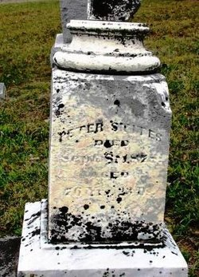

No further information found at this time

