Matilda Richards
June 14, 1851 – March 18, 1898

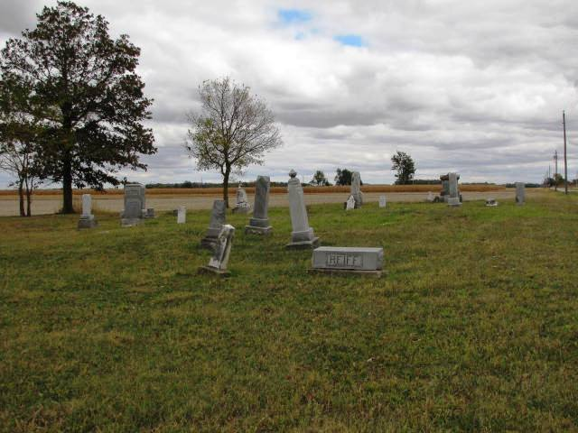

Matilda Richards
in the Indiana, U.S., WPA Death Index, 1882-1920
Name: Matilda Richards
Date: Mar 18, 1898
Location: Adams County
Age: 42 Yr
Gender: Female
Race: White
Source location: County Health Office, Decatur
Source notes: The source of this record is the book H-19 on page 194 within the series produced by the Indiana Works Progress Administration.

