Enoch Reiff
1832 - 1898

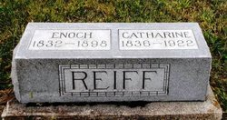

No further information found at this time

