M. Frederick Rapp
August 21, 1839 – March 15, 1913

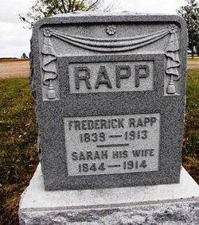

M F Rapp
in the Indiana, U.S., Death Certificates, 1899-2011
Name: Mr. F Rapp
Gender: Male
Race: White
Age: 73
Marital status: Married
Birth Date: 21 Aug 1839
Birth Place: Germany
Death Date: 15 Mar 1913
Death Place: Jefferson, Wells, Indiana, USA
Father: Fredrick Rapp
Mother: Rossana
Spouse: Sarah
Informant: Sarrah Rapp; Ossian, Indiana
Burial: March 17, 1913; Bethelhem [sic]Cemetery

