Mary Elisabeth Engle
June 8, 1845 – November 3, 1848

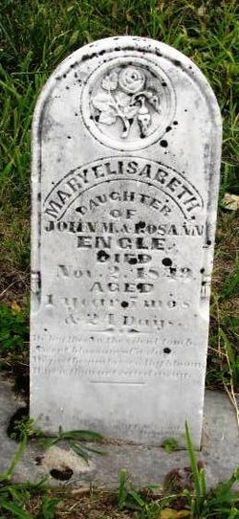

No further information found at this time

