Mary Ann Engle
May 26, 1852 - June 29, 1870

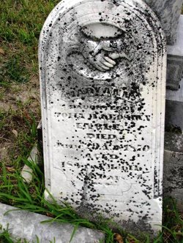

No further information found at this time

