Lydia (Engle) Caston
June 26, 1867 – October 26, 1889

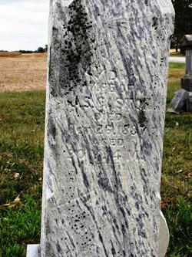

No further information found at this time

