William H. Zwick
March 23, 1875 – August 2, 1944

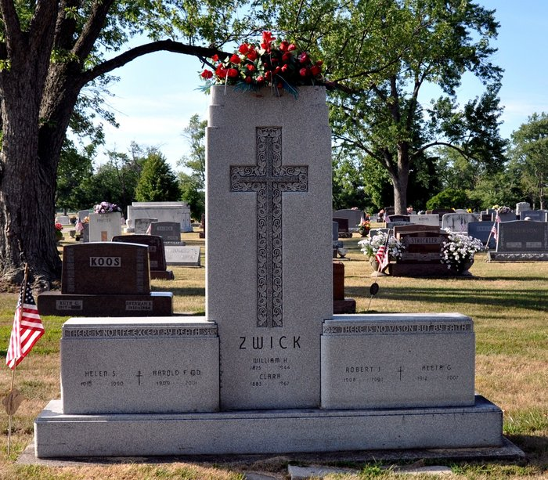
Photo by Deb Curry

William H Zwick
in the Indiana, U.S., Death Certificates, 1899-2017
Name William H Zwick
Gender Male
Race White
Marital Status Married
Age 69
Birth Date 23 Mar 1875
Birth Place Preble Twp Adams Co Indiana
Death Date 2 Aug 1944
Death Place Decatur, Adams, Indiana, USA
Death Registration Date 1944
Father Charles Zwick
Mother Wilhelmina Heckman
Spouse Clara Wischmeier; age 61
Informant Robert J. Zwick; Decatur, Indiana
Burial August 5, 1944; Decatur Cemetery; Decatur, Indiana

