Robert James Zwick
May 3, 1908 – June 12, 1993

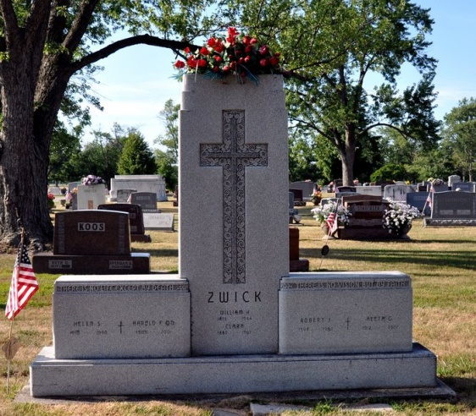
Photo by Deb Curry

Robert J. Zwick, 85, of Decatur died Saturday in Adams County Memorial Hospital. The Decatur native retired after 60 years as a director and owner of the Decatur Funeral Home. He also was Adams County Coroner for two terms.
Surviving are his wife, Aleta G.; sons, William H. and Zane R., both of Decatur; sisters, Irene K. Zwick and Leona Sheets, both of Fort Wayne, and Margaret Auer of Decatur; a brother, Harold F. of Decatur; and three grandchildren.
Services are 11 a.m. Wednesday in Zion Lutheran Church, Decatur, with burial in Decatur Cemetery. Calling is 7 to 9 p.m. today, and 2 to 5 and 7 to 9 p.m. tomorrow in Zwick-Sefton & Jahn Funeral Home, Decatur, and 10 to 11 a.m. Wednesday in the church.
Preferred memorials are gifts to Robert J. Zwick Christian Education Grant Fund.

News-Sentinel, Allen County, Indiana
June 14, 1993

**
Indiana, U.S., Death Certificates, 1899-2017
Name Robert James Zwick
Gender Male
Race White
Marital Status Married
Age 85
Birth Date 3 May 1908
Birth Place Decatur, in 46733
Death Date 12 Jun 1993
Death Place Decatur, Adams, Indiana, USA
Father William H Zwick
Mother Clara Wischmeyer
Spouse Aleta G.
Informant Aleta G. Zwick; wife; Decatur, Indiana
Burial June 16, 1993; Decatur Cemetery; Decatur, Indiana

