Phyllis J. (McFarland) Zwick
July 22, 1925 – December 17, 2020

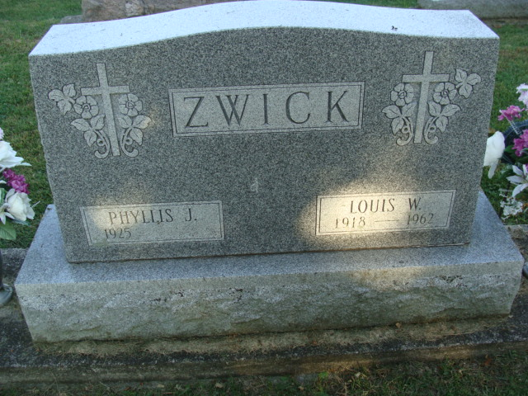
Photo by Alicia Kneuss

Phyllis J. Zwick, 95, of Decatur, Indiana passed away Thursday, December 17, 2020, at Adams Memorial Hospital with her daughter by her side. She was not in failing health and death was unexpected and followed natural causes.
She was born on July 22, 1925 in Decatur, Indiana to the late Therald Gregg McFarland and the late Velma Vera (Alfather) McFarland. Phyllis was united in marriage to Louis W. Zwick on October 12, 1946 and he preceded her in death on June 2, 1962.
She was a member of Zion Lutheran Church in Decatur where she was a charter member of the Emmaus Guild. Additionally, she remained involved in the American Legion Post 43 Auxiliary as Louis was also a member as a veteran of the United States Army having served during World War II.
Phyllis was a homemaker, treasuring the time spent raising her daughters, especially following the sudden loss of Louis in 1962. In addition, she was also employed with the Adams Memorial Hospital in the Business and Admitting Departments where she retired in 1990 following 23 years of service. For many years she was known as the “Voice of the Radio” as she provided details of admissions at the hospital over the local radio station, WZBD.
Phyllis had several favorites in life, but her family was especially important to her; her daughters, grandchildren, great grandchildren…and even sons-in-law. She spent countless hours crocheting, making sure that her grandchildren had sweaters, baby blankets, afghans, and baptismal gowns.
She is survived by two daughters, Sharon (Ray) Viktorin of El Campo, Texas and Barbara (Jack) Harvey of Decatur, Indiana; four grandchildren, Nicole (Jim) Hogan, Mark (Jen) Schwartz, Scott (Abby) Harvey, and Krista (Nate) Frey; and nine great grandchildren, Landen Harvey, Alexis Harvey, Maddox Frey, Mason Frey, Mackenzie Frey, Teegan Schwartz, Sloane Schwartz, Spencer Hogan, and Harper Hogan. She was preceded in death by a granddaughter, Stacy Harvey who died in infancy.
A funeral service will be held at 11:00 a.m. Monday, December 21, 2020, at the Zion Lutheran Church, Decatur with Pastor James Voorman officiating. Burial will follow at the Decatur Cemetery. The service will be recorded on the Zion Lutheran Church Youtube channel (Zion Lutheran Decatur) and will be available later in the day on Monday. Masks will be required.
Friends and family will be received from 9:30 a.m. to service time at the church on Monday.
Preferred memorials are to Zion Lutheran Church Gardening Angels.

Zwick & Jahn Funeral Home, Adams County, Indiana
December 18, 2020

