Louis W. Zwick
December 26, 1918 – June 2, 1962

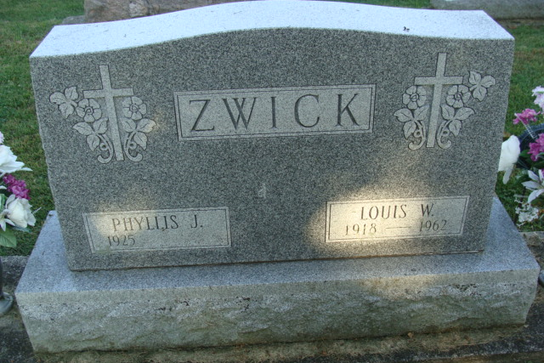
Photo by Alicia Kneuss

EMPLOYEE OF LOCAL PLANT IS STRICKEN
LOUIS W. ZWICK, 43, OF DECATUR, DIES SUDDENLY

Louis W. Zwick, 43, who resided at 1515 W. Monroe St., Decatur, died unexpectedly at 7:30 p.m. Saturday while a customer at Meyers Service Station in Decatur.
Born in Preble Township December 26, 1918, he was the son of Anna Trier Zwick and the late Edward Zwick. He was married on October 12, 1947 to the former Phyllis McFarland.
Surviving are the wife, two daughters at home, Sharon and Barbara; and a brother Edgar of Fort Wayne. A brother preceded in death.
A veteran of World War II, he had been an employee of Micromatic Hone Corp., Berne, for two years.
Services will be at 1:30 p.m. at the Zwick Funeral Home in Decatur, and at 2 p.m. in the Zion Lutheran Church, of which he was a member, with Rev. Richard C. Ludwig officiating. Military graveside services will be held by the American Legion Adams Post 43 in the Decatur Cemetery. Friends may call at the funeral home until time of the services.

Adams County (IN) Historical Museum
January 1951 – August 1962 Scrapbook, image 69
Handwritten date: Monday, June 4, 1962

