Irene Kathryn Zwick
August 30, 1903 – July 17, 1993

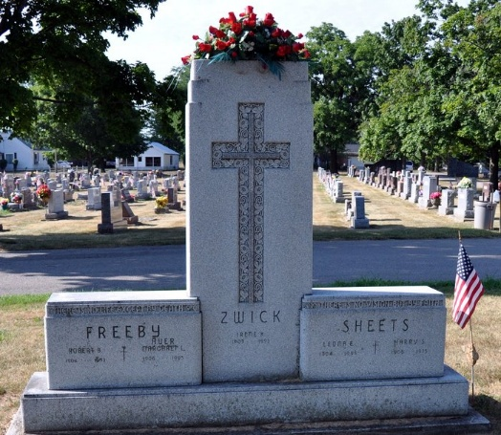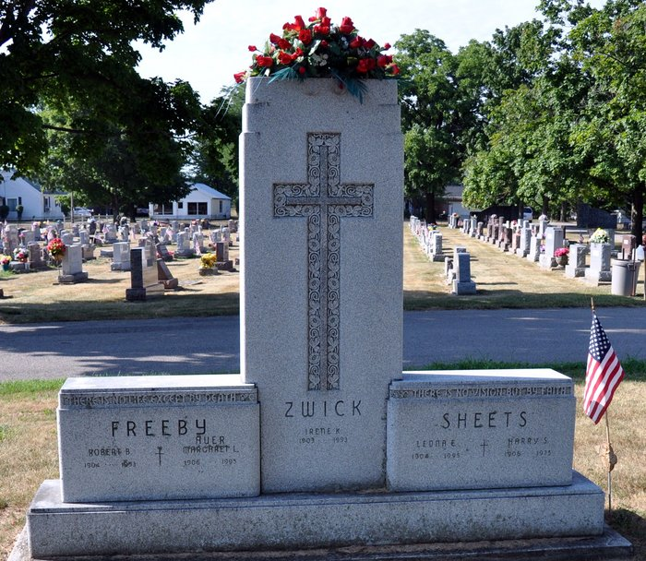
Photo by Deb Curry

Irene K. Zwick, 89, of Fort Wayne died Saturday in Regency Place. The Decatur native retired as a partner in the Zwick-Sefton & Jahn Funeral Home, Decatur, in 1985 after 59 years.
Surviving are sisters, Leona Sheets of Fort Wayne and Margaret Auer of Decatur; and a brother, Harold F. of Decatur.
Services are 11:30 a.m. Wednesday in Zion Lutheran Church, Decatur, with burial in Decatur Cemetery. Calling is 2 to 5 and 7 to 9 p.m. tomorrow in the funeral home, and 10:30 a.m. to 11:30 a.m. Wednesday in the church.
Preferred memorials are gifts to Robert J. Zwick Christian education grant fund.

News-Sentinel, Allen County, Indiana
July 19, 1993

**
Indiana, U.S., Death Certificates, 1899-2017
Name Irene Kathryn Zwick
Gender Female
Race White
Marital Status Never Married (Single)
Age 89
Birth Date 30 Aug 1903
Birth Place Decatur, Indiana
Death Date 17 Jul 1993
Death Place Fort Wayne, Allen, Indiana, USA
Death Registration Date 1993
Father William H Zwick
Mother Clara Wischmeyer
Informant Leona Sheets, sister
Burial Jul 21, 1993 Decatur Cemetery

