Helen S. (Shroll) Zwick
June 27, 1910 – May 23, 1990

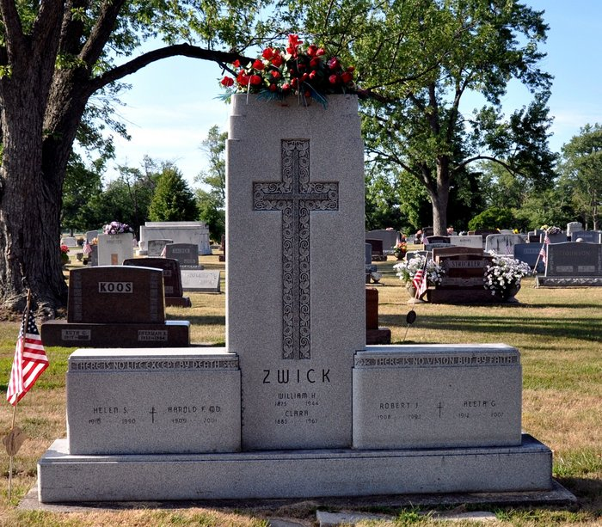
Photo by Deb Curry

Helen S Zwick
in the Indiana, U.S., Death Certificates, 1899-2017
Name Helen S Zwick
[Helen S Shroll]
Gender Female
Race White
Marital Status Married
Age 79
Birth Date 27 Jun 1910
Birth Place Decatur, Indiana
Death Date 23 May 1990
Death Place Fort Wayne, Allen, Indiana, USA
Death Registration Date 1990
Father Harve N Shroll
Mother Callie L Tester
Spouse Dr. Harold F Zwick
Informant Dr. Harold Zwick; husband; Decatur, Indiana
Burial May 25, 1990; Decatur Cemetery; Decatur, Indiana

