Dr. Harold F. Zwick
October 12, 1909 – December 2, 2001

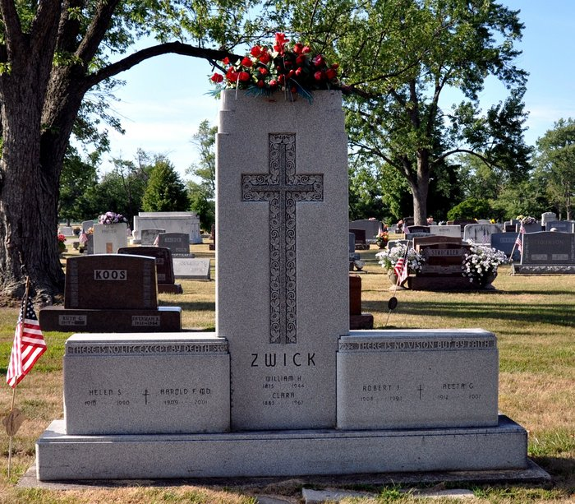
Photo by Deb Curry

Dr. Harold F. Zwick, 92, of Decatur, a physician and surgeon, died Sunday, Dec. 2, 2001, at Woodcrest. The Adams County native had retired from practice in 1988 after more than 52 years of service and had served as the medical director at Lakeside Nursing Home for several years. He had been chief of staff at Adams County Memorial Hospital and was a member of Zion Lutheran Church where he sang in the church choir and men's choir. He was a charter member of Lutheran Chorale, a 50-year member of American Legion Adams Post 43 and Lions Club. He was a World War II U.S. Army veteran and a recipient of the Bronze Star.
Surviving are daughters Maryann Cowans of Decatur and Barbara J. Johnson of Fort Wayne; a son, Dr. H. Frederick Jr. of Whitehall, Wis.; six grandchildren; and six great-grandchildren. He was preceded in death by his wife, Helen N., three sisters and a brother.
Services are 11 a.m. Thursday at Zion Lutheran Church, Decatur, with calling one hour before services. Calling is also from 1 to 8 p.m. Wednesday at Zwick & Jahn Funeral Home, Decatur. Burial with military graveside services will be at Decatur Cemetery.
Memorials are to Zion Lutheran Choir or Adams County Memorial Hospital.

News-Sentinel, Allen County, Indiana
December 4, 2001

**
Harold F Zwick
in the Indiana, U.S., Death Certificates, 1899-2017

Name Harold F Zwick
Gender Male
Race White
Marital Status Widowed
Age 92
Birth Date 12 Oct 1909
Birth Place Adams County, Indiana
Death Date 2 Dec 2001
Death Place Decatur, Adams, Indiana, USA
Death Registration Date 2001
Father William H Zwick
Mother Clara H Wischmeyer
Informant Maryann Cowans; daughter; Decatur, Indiana
Burial December 6, 2001; Decatur Cemetery; Decatur, Indiana

