Clara (Wischmeyer) Zwick
March 17, 1883 – February 18, 1967

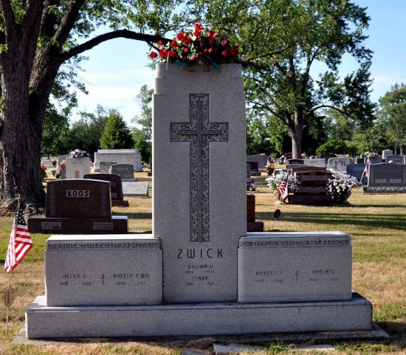
Photo by Deb Curry

Clara Zkick
in the Indiana, U.S., Death Certificates, 1899-2017
Name Clara Zwick
[Clara Wischmeyer]
Gender Female
Race Caucasian (White)
Marital Status Widowed
Age 83
Birth Date 17 Mar 1883
Birth Place Indiana
Death Date 18 Feb 1967
Death Place Decatur, Adams, Indiana, USA
Death Registration Date 1967
Father Henry Wischmeyer
Mother Katherine Hambrock
Informant Irene K. Zwick; daughter; Decatur, Indiana
Burial February 20, 1967; Decatur, Indiana

