Aleta G. (Harlow) Zwick
May 10, 1912 – March 26, 2007

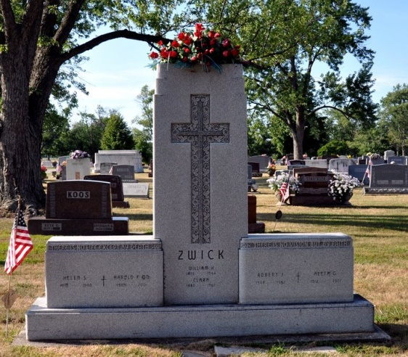
Photo by Deb Curry

Aleta G. Zwick, 94, of Decatur, died at 2:20 a.m. on Monday, March 26, 2007 at the Adams Memorial Hospital where she had been a patient for 3 days. Aleta was born on May 10, 1912 in Adams County, Indiana, the only child of Albert and Cora (Shoemaker) Harlow. Following her graduation from high school, she also attended the John Herron School of Art, Butler University. After moving to Decatur in the early 1930s, she met Robert J. Zwick. She was united in marriage to Bob in May 19, 1935 in Indianapolis, Indiana. Bob preceded her in death on June 12, 1993 after they had celebrated 58 years of marriage.
Aleta was a member of the Zion Lutheran Church, Decatur where she was involved with the Missionary Society, was a former Sunday School Teacher and Vacation Bible School Teacher and also a former member of the choir. She was also an Inactive Honorary Member of the Psi Iota Xi Sorority. Aleta was a homemaker who also assisted in the operation of Zwick Funeral Home, now operated as Zwick & Jahn Funeral Homes in Decatur and Monroeville.
Aleta is survived by 2 sons: Zane R. Zwick of Decatur, Indiana and William H. (Eileen) Zwick of Decatur, Indiana; 3 Grandchildren: Jonathan R. (Cathy) Zwick; William F. (Carrie) Zwick; Amy Zwick and 4 Great-Grandchildren: Christian Zwick, Laurel Zwick, Mi-Ree Zwick, and William F. Zwick II. She was preceded in death by a great-grandson, Isaac Samuel Zwick.
Funeral services for Aleta will be held at 11:00 a.m. on Saturday, March 31, 2007 in the Zion Lutheran Church, Decatur with Pastor Scott Bruick and Pastor Daniel Gadbaw officiating. Burial will follow the services at Decatur Cemetery. Friends and family will be received from 2-4 and 6-8 p.m. Friday in the Zwick & Jahn Funeral Home, Decatur and one hour prior to services Saturday at the church.
Preferred memorials are to the Robert J. and Aleta G. Zwick Scholarship Fund through Zion Lutheran Church; Decatur, Zion Lutheran Church, Decatur; Redeemer Lutheran Church, Englewood, Florida; or Englewood Beach Condominium Association Women’s Association.

Zwick & Jahn Funeral Home, Adams County, Indiana
March 27, 2007

