John M. Zuber
December 29, 1951 – August 9, 2014

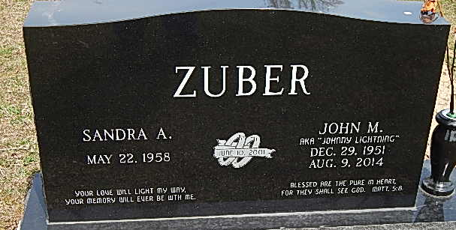
Photo by Alicia Kneuss

John M. Zuber, 62 years old of Decatur, Indiana, passed away on Saturday, August 9, 2014 in Decatur. He was born on Saturday, December 29, 1951 in Fort Wayne, Indiana the son of the late James Zuber and Florine (Stoeckly) Zuber. He married Sandi Peveler on June 10, 2001 in Brown County, Indiana.
John was a member of New Beginnings Family Center in Decatur.
He was employed for 43 years with American Electric Power as a serviceman.
Surviving are his wife, Sandi Zuber of Decatur; son, Tony Zuber of Fort Wayne; son, Bryan (Bernadette) Zuber of Columbus, Georgia; son, Jason Zuber of Decatur; step-daughter, Patsy (Rob) Kraj of Marietta, Georgia, mother, Florine Schneider of New Haven; brother, James (Cheryl) Zuber of New Haven; sister, Sharon (Dean) Huey of Columbus, Nebraska; sister, Mary (Phil) Raimondo of Columbus, Nebraska; and eight grandchildren.
Funeral services will be held at 10:30 a.m. Wednesday, August 13, 2014 in the Zwick & Jahn Funeral Home in Decatur with Pastor Jason Cooksey officiating. Interment will follow in the Decatur Cemetery.
Friends will be received from 1 to 4 and 5 to 8 p.m., Tuesday, August 12 in the Zwick & Jahn Funeral Home in Decatur.
Preferred memorials are to Doctors Without Borders.

Zwick & Jahn Funeral Home, Adams County, Indiana
August 21, 2014

