Jerry Lee Zinsmaster
August 23, 1940 – June 29, 2011

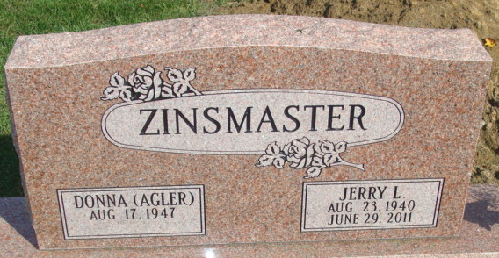
Photo by Alicia Kneuss

Jerry L. Zinsmaster, 70, of Decatur, Indiana died Wednesday, June 29, 2011 at Lutheran Hospital. Jerry was born on August 23, 1940 in Logansport, Indiana to Louis C. and Geneva S. (Bowen) Zinsmaster.
Jerry is a retired auto worker and served in the United States Marines.
Survivors include his wife Donna J. Weitfeldt Zinsmaster of Decatur; five sons Anthony Zinsmaster of Oklahoma, Eric Zinsmaster of Ohio, Bryan (Fawn) Wietfeldt, Donald (Lesa) Wietfeldt and David Wietfeldt of Decatur; three daughters Laura (Jeff) Shaffer and Kristine (Tony) Peterson of Decatur and Sandra (Joe) Thomas of Convoy, OH; 19 grandchildren and 9 great grandchildren.
Jerry is preceded in death by his parents, three brothers Harold, Donald and Richard; two sisters Betty Teeple and Shirley Easter and a great granddaughter Natalie Ann Roll.
Visitation will be from 3-7 p.m. on Friday, July 1, 2011 at Haggard-Sefton and Hirschy Funeral Home. Funeral Services will be on Saturday, July 2, 2011 at 10:00 a.m. also at the funeral home. Pastor Rex Grant will be officiating and burial will be in Decatur Cemetery.
Memorials are to the Family.

Haggard - Sefton & Hirschy Funeral Home, Adams County, Indiana
June 30, 2011

