Nora Lee (Ray) Ziner
1936 -

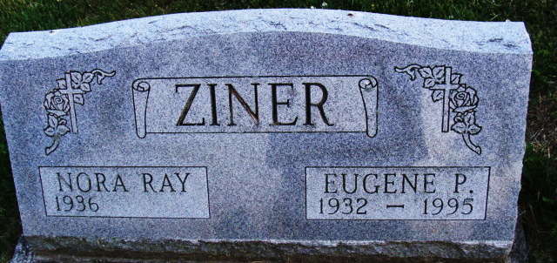
Photo by Alicia Kneuss

