Miriam C. (Keaffaber) Ziner
April 6, 1905 – August 12, 1998

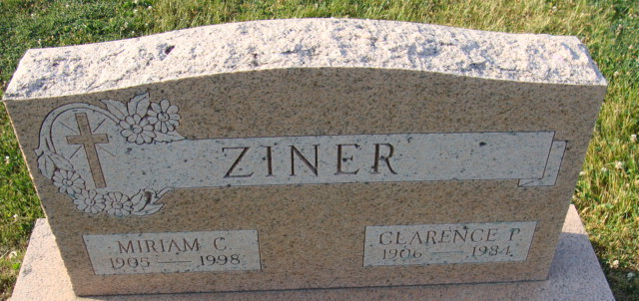
Photo by Alicia Kneuss

Miriam C. Ziner, 93, of Decatur, who for many years was the co-owner of Ziner's Culligan Water Conditioning, died Wednesday, Aug. 12, in Woodcrest Nursing Center. Ziner, who was born in Wabash County, had lived in Decatur for 60 years. She was a member of First Presbyterian Church, Decatur, Eastern Star Chapter 127 and Daughters of the Nile.
Surviving are three grandchildren, eight great-grandchildren and one great-greatgrandchild. Her husband, Clarence P., died in 1984, and her son, Gene P., died in 1995.
Services are 11 a.m. Saturday at Haggard & Sefton Funeral Home, Decatur, where calling begins at 10 a.m. Burial will be in Decatur Cemetery.
Memorials are to the church memorial fund.

News-Sentinel, Allen County, Indiana
August 14, 1998

**
Indiana, U.S., Death Certificates, 1899-2017
Name Miriam C Ziner
[Miriam C Keaffaber]
Gender Female
Race White
Marital Status Widowed
Age 93
Birth Date 6 Apr 1905
Birth Place Wabash County
Death Date 12 Aug 1998
Death Place Decatur, Adams, Indiana, USA
Father Phillip Keaffaber
Mother Elizabeth Gimmer
Informant Nora Ziner; daughter-in-law; North Port, Florida
Burial August 15, 1998; Decatur Cemetery; Decatur, Indiana

