Eugene Paul Ziner
January 29, 1932 – October 27, 1995

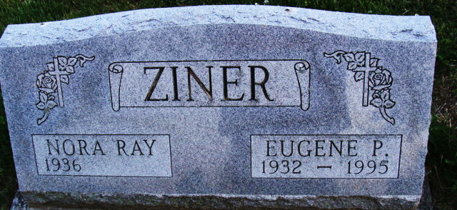
Photo by Alicia Kneuss

Eugene P. Ziner, 63, of Spring, Texas, died yesterday at Methodist Hospital Medical Center in Houston. The Fort Wayne native worked at Water Conditioning Co. and was a Korean War Navy veteran. He resided in Decatur before moving to Texas.
Surviving is his wife, Nora Ray Ziner; a daughter, Christina M. Jentz of Spring; sons, Michael D. Ziner of Wasau, Wis., and Phillip D. Ziner of North Port, Fla.; his mother, Miriam C. Keaffaber Ziner of Spring; and 11 grandchildren.
Private services are Tuesday at Haggard & Armes Funeral Home, Decatur, where calling is from 10 to 11 a.m. Tuesday. Burial will be in Decatur Cemetery with Masonic graveside services.
Memorials are to the American Cancer Society.

News-Sentinel, Allen County, Indiana
October 28, 1995

**
Texas, U.S., Death Index, 1903-2000
Name Eugene Ziner
Death Date 27 Oct 1995
Death County Harris
Gender Male
**
U.S., Social Security Applications and Claims Index, 1936-2007
Name Eugene Paul Ziner
Gender Male; Race White
Birth Date 29 Jan 1932; Birth Place Ft Wayne All, Indiana
Death Date 27 Oct 1995
Father Clarence P Ziner
Mother Miriam C Keaffaber
SSN xxx
Notes Jan 1948: Name Listed As Eugene Paul Ziner; 03 Nov 1995: Name Listed As Eugene P Ziner

