Clarence P. Ziner
January 31, 1906 – July 13, 1984

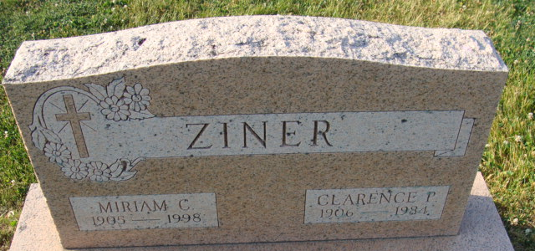
Photo by Alicia Kneuss

Clarence P. Ziner
in the Indiana, U.S., Death Certificates, 1899-2017
Name Clarence P. Ziner
Gender Male
Race White
Marital Status Married
Age 78
Birth Date 31 Jan 1906
Birth Place Indiana
Death Date 13 Jul 1984
Death Place Fort Wayne, Allen, Indiana, USA
Death Registration Date 1984
Father Charles Ziner
Mother Elizabeth Gemmer
Spouse Miriam Keaffaber
Informant Miriam Ziner; wife; Decatur, Indiana
Burial July 16, 1984; Decatur Cemetery; Decatur, Indiana

