Florence D. (Hindenlang) Zimmerman-Storm
December 31, 1898 – May 26, 1977

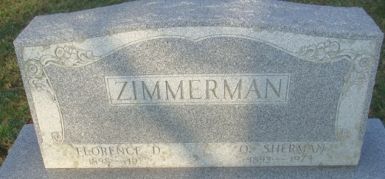
Photo by Alicia Kneuss

Florence D. Zimmerman Storm, 78, 1209 West Madison St., Decatur, died at 2:15 am Thursday at the Adams County Memorial Hospital, where she had been a patient one day.
She was a member of the First United Methodist Church for more than 50 years.
Born in Union Township on December 31, 1898, she was the daughter of George and Ida Miller-Hindenlang; Sr. She was married on May 9, 1973 to Fred E. Storm, who survives. She was first married to O. Sherman Zimmerman on December 23, 1916 and he died January 1, 1973.
Also surviving are one stepson, Lester Storm, Convoy, Ohio; two sisters, Mrs. Chancey (Maggie) Barlett, Fort Wayne; Mrs. Howard (Myrtle) Cramer, Fort Wayne; one brother, George Hindenlang, Jr., Decatur; one half-brother, Paul Hindenlang, Decatur and four step grandchildren. Four brothers and one sister preceded her in death.
Funeral services will be held at 2:30 pm Sunday at the Winteregg-Linn & Haggard Funeral Home, with Rev. Harold L. Leininger officiating. Burial will be in the Decatur Cemetery.
Friends may call at the funeral home after 7 pm today.

From the Florence Gause Collection
1977

**
Indiana, Death Certificates, 1899-2011

Name: Florence D. Storm [Florence D. Hindelang]
Gender: Female; Race: White
Age: 78
Marital status: Married
Birth Date: 31 Dec 1898; Birth Place: Indiana
Death Date: 26 May 1977; Death Place: Decatur, Adams, Indiana, USA
Father: George Hindelang
Mother: Ida Hindelang
Spouse: Fred E. Storm, informant
Burial: 5/29/1977, Decatur Cemetery

