Stephanie A. Zimmerman
October 25, 1965 – October 29, 1965

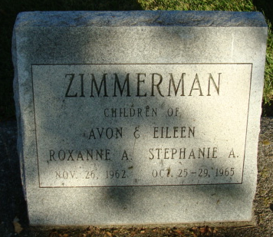
Photo by Alicia Kneuss

Stephanie Anne Zimmerman
in the Indiana, U.S., Death Certificates, 1899-2017
Name Stephanie Anne Zimmerman
Gender Female
Race Caucasian (White)
Age 4 days
Birth Date 25 Oct 1965
Birth Place Indiana
Death Date 29 Oct 1965
Death Place Decatur, Adams, Indiana, USA
Death Registration Date 1965
Father Avon Zimmerman
Mother Eileen Hanni
Informant Avon Zimmerman; father; Decatur, Indiana
Burial October 30, 1965; Decatur Cemetery; Decatur, Indiana

