Roxanne A. Zimmerman
November 26, 1962 – November 26, 1962

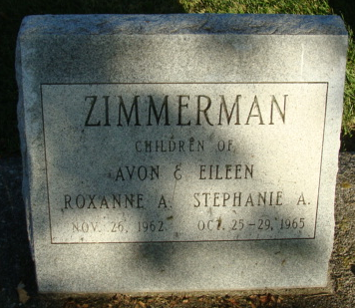
Photo by Alicia Kneuss

Roxanne Zimmerman
in the Indiana, U.S., Death Certificates, 1899-2017
Name Roxanne Zimmerman
Gender Female
Race White
Age 10 minutes
Birth Date 26 Nov 1962
Birth Place Indiana
Death Date 26 Nov 1962; premature
Death Place Decatur, Adams, Indiana, USA
Death Registration Date 1962
Father Avon Zimmerman
Mother Eileen Fay Hannie
Informant Avon Zimmerman; father; Decatur, Indiana
Burial November 27, 1962; Decatur Cemetery; Decatur, Indiana

