Phyllis L. (Gerke) Zimmerman
October 18, 1931 – November 28, 2005

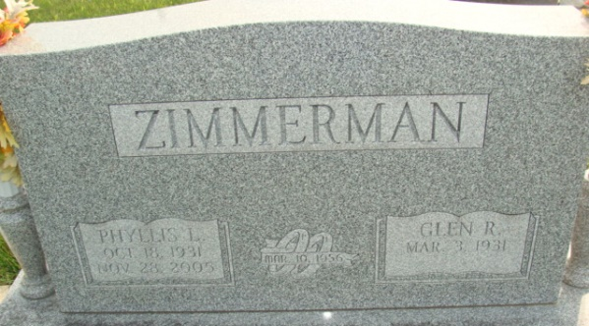
Photo by Alicia Kneuss

Phyllis L. Zimmerman, 74, of Decatur, died Monday, Nov. 28, 2005 following a brief illness. She was born on October 18, 1931 in Adams County, Ind. Phyllis was a production scheduler at General Electric in Decatur Plant for 39 years and also assisted her husband with the farm operation and auto sales. She was a member of Zion Lutheran Church, Decatur.
Phyllis is survived by her husband, Glen R. Zimmerman; sister, Mrs. Tom (Shirley) Noll; and brother, Gail Gerke, all of Decatur. She is predeceased by her parents, Winifred L. Gerke and Miriam (Myers) Gerke.
Visitation is 2 to 4 and 5 to 8 p.m. Thursday at the Zwick and Jahn Funeral Home with service at 10:30 a.m. Friday at the funeral home. Burial will be at the Decatur Cemetery.
Preferred memorials are to the Visiting Nurse & Hospice Home of Fort Wayne or Zion Lutheran Church, Decatur.

News-Sentinel, Allen County, Indiana
November 30, 2005

