Malinda (Drayer) Zimmerman
June 12, 1848 – November 28, 1932

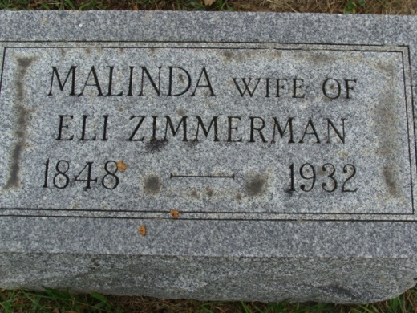
Photo by Alicia Kneuss

FORMER LOCAL WOMAN EXPIRES
Malinda Zimmerman Is Death's Victim at Ft. Wayne Hospital

Mrs. Malinda Zimmerman, 84, of Fort Wayne for many years, a resident here, died yesterday the Anthony Wayne Hospital in Fort Wayne, after a six weeks illness with senility. Mrs. Zimmerman was born in Berks Co., Pennsylvania and came here when a girl. She married Eli Zimmerman who owned a section of land just east of Decatur and for years the family was one of the best known in this county. After the death of her husband, Mrs. Zimmerman married William Frobfield who died about fifteen years ago.
One son, George Zimmerman, survives, residing in Fort Wayne also.
Private funeral services will be held tomorrow afternoon at one o'clock from the Schone Funeral Home. Dr. Charles H. Smith officiating and burial will be in Maple Grove Cemetery.

Decatur Daily Democrat, Adams County, Indiana
November 30, 1932

**
For the seventh time Mrs. Malinda Fronefield, at Decatur, has filed suit for divorce from William C. Fronefield. They have been twice divorced and three times married to each other, and the remaining times the suits were dismissed before coming to trial.

Fort Wayne Sentinel; Allen County, Indiana
September 29, 1909

**
Indiana, Death Certificates, 1899-2011

Name: Malinda Zimmerman
Gender: Female
Race: White
Age: 83
Marital Status: Widow
Birth Date: 12 Jun 1848
Birth Place: Berks County, PA
Death Date: 28 Nov 1932
Death Place: Indiana, Allen, Indiana, USA
Mother: Malinda Drayer ???
Spouse: Eli Zimmerman
Informant: George Zimmerman
Burial: Dec. 1, 1932 Maple Grove Cem., Decatur, Indiana

