Leona Elizabeth (Hirschy) Zimmerman
March 19, 1897 – September 16, 1978

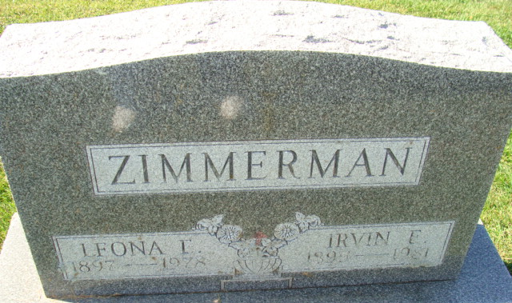
Photo by Alicia Kneuss

Leona Zimmerman

Mrs. Leona Elizabeth Zimmerman, 81, Route 4, Decatur, died at 3:10 p.m. Saturday at the Adams County Memorial Hospital following an extended illness. A native of Adams County, Mrs. Zimmerman was a member of the First Baptist Church of Decatur and was born on March 19, 1897, to Henry and Anna Bauman Hirschy. She was married on October 13, 1917, to Irvin E. Zimmerman, who survives.
Other survivors include seven brothers, Fred, John, Henry, and Elmer, all of Decatur, Alfred, of Monroe, Carl, Route 6, Decatur, and Amos, Route 1, Monroe; two sisters, Mrs. Milo (Mary) Fuchs, of Monroe, and Mrs. Dora Fox, of Decatur.
Funeral services will be held Tuesday at 1:30 p.m. at the Winteregg-Linn and Haggard Funeral Home with the Rev. Bruce Collier officiating. Burial will be in the Decatur Cemetery. Friends may call after noon today at the funeral home.

Decatur Daily Democrat, Adams County, Indiana
September 18, 1978

