Janice A. (Liechty) Zimmerman
December 20, 1943 – August 28, 1970

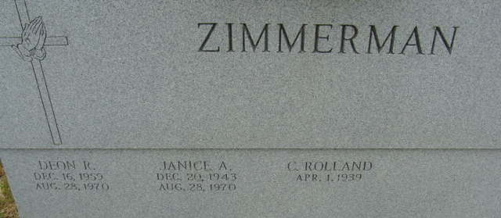
Photo by Alicia Kneuss

Decatur Lady Killed - Two Sons Injured Late this Morning as Auto Hits Tree South of the City

Tragedy struck Decatur and Adams County late this morning when Mrs. Rolland (Janice) Zimmerman, 26, of 320 ½ Winchester St., was fatally injured when the car she was driving went out of control on U. S. Highway 33 just south of Decatur and went down a steep embankment. The one-car accident took place shortly before 11 a.m. this morning just south of the Decatur Church of God and the new Lakeview Nursing Home.
The two Zimmerman children, Troy, 8, and Deon, 10, were both injured as the result of the mishap and were rushed by ambulance to the Fort Wayne Lutheran Hospital. The extent of their injuries was not known at press time.
Mrs. Zimmerman was the daughter of Mr. and Mrs. Mel Liechty of Route 1, Berne. Liechty is a well-known realtor and auctioneer.
Loses Control
The accident occurred when a car driven by Mrs. Zimmerman, northbound on the Federal Highway, went off the right side of the roadway. Apparently, in her attempt to bring the station wagon back onto U. S. Highway 33, Mrs. Zimmerman lost control of the vehicle, and the auto went across the highway, leaving the left side of the roadway, and went down a steep embankment, crashing head-on into a tree at the bottom of the 15-foot embankment.
Mrs. Zimmerman was an active member of the Decatur Church of God, serving with her husband as youth counselors for the church’s youth fellowship.
Adams County has now recorded 11 traffic deaths in 1970, eight occurring in the county and three taking place within the city limits of Decatur.
Investigating the accident and helping at the accident scene included Harold Schindler, Adams County Deputy Sheriff; Bill Crone, Ray Seitz, Nick Secaur and Jerry Villagomez from the Decatur Police Department.

Decatur Daily Democrat, Adams County, Indiana
Friday, August 28, 1970

