Isaac W. Zimmerman
June 30, 1868 – April 1, 1916

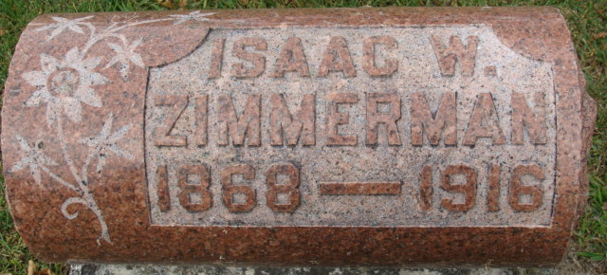
Photo by Alicia Kneuss

WAS A SUICIDE
Isaac Zimmerman Killed Himself in a Fit of Despondency.
Left Note For A Pal - Explaining His Act - Was Recently in an Explosion.

The body of Isaac Zimmerman, who shot himself Saturday afternoon at 1:30 o'clock, at the home of his mother Mrs. Malinda Fronfield, was brought to Decatur this afternoon from Fort Wayne on the 2:30 o'clock car.
Funeral services were held at the home of his mother in Fort Wayne before shipping the body. From the car the body was taken to the Maplewood Cemetery where interment was made. Mr. Zimmerman was forty-seven years old and was recently in the explosion at the Western Gas Construction Company's plant when a dye vat exploded. Depression and injuries sustained at that time are attributed as the cause of the suicide.
The Journal Gazette said in part: "Isaac W. Zimmerman, forty-seven years old, an employee of the Western Gas Construction Company, committed suicide yesterday afternoon shortly after 1:30 o'clock by shooting himself through the head with a 32 caliber revolver in a bedroom at his home, 617 Holman Street. The body was found stretched out upon the floor with the weapon beside it when his mother, Mrs. M. Fronfield, returned home after a few hours' absence. She could not find him and a search of the house led her to her son's room where the unfortunate man had shut himself in before firing the fatal shot. Shocked by the discovery, the mother gave the alarm, and Dr. A. L. Schneider was called, who found that the death had been instantaneous."
Isaac W. Zimmerman, aged 47 years, and one of the three employees of the Wester Gas Construction Company injured several weeks ago in the explosion of the dye works at the plan, shot himself through the head with a 32 caliber revolver in a bedroom of his home, 617 Holman Street, shortly after 1:30 Saturday afternoon. He had been acting sullen for several days, and was greatly depressed because of his injuries. His mother, Mrs. M. Fronfield, had left the home shortly after eleven o'clock and when she returned called to her son, and receiving no response had opened the door of his room. Half-dressed and spread on the floor, his head under the bed, she saw the body of her son and beside it a revolver. Dr. A. L. Schneider was called and found that death had been instantaneous. Although there is only one hole in the dead man's head, two of the chambers of the gun had been exploded. Neighbors heard but one shot. Investigation by Coroner J. E. McArdle disclosed a note left by the suicide. It was addressed to Jack Burke, another employee of the Western Gas Company. The note is as follows: "Good night. I am going to all. Good night. Give Jack my best and Mr. Perry, too. I am going to shoot. You know where my watch is and the $150 loan. Good night." - Ft. Wayne Sentinel.

Decatur Daily Democrat, Adams County, Indiana
April 3, 1916

**
Indiana, U.S., Death Certificates, 1899-2017
Name Isaac W. Zimmerman
Gender Male
Race White
Marital Status Married
Age 47
Birth Date 30 Jun 1868
Birth Place Indiana
Death Date 1 Apr 1916; suicide by gunshot
Death Place Fort Wayne, Allen, Indiana, USA
Father Eli Zimmerman
Mother Malinda Drayer
Informant Malina Drayer; Fort Wayne, Indiana
Burial April 3, 1916; Decatur, Indiana

