Irvin E. Zimmerman
May 17, 1895 – February 4, 1981

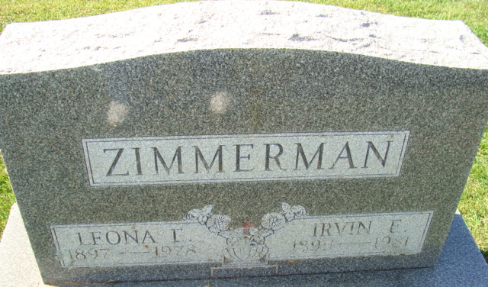
Photo by Alicia Kneuss

Irvin E. (Cuffy) Zimmerman, 85, a resident of the Decatur Community Care Center, died at 7:50 a.m. today at the Adams County Memorial Hospital where he had been hospitalized one week. He was a retired farmer and onetime employee of the Kocher Lumber Co. He was a member of the First Baptist Church. Born on May 17, 1895, in Adams County, he was the son of Lewis and Ethel Beavers Zimmerman, and was married on Oct. 13, 1917, to Leona Hirschy; she died Sept. 16, 1978.
Survivors include one brother, Ben Zimmerman, Rapids City, Mich.; and several nieces and nephews. Five brothers preceded him in death.
Funeral services will be held Friday at 2:30 p.m. at the Winteregg-Linn & Haggard Funeral Home, with Rev. Bruce Collier officiating. Burial will be in the Decatur Cemetery. Friends may call at the funeral home Thursday from 2 to 5 and 7 to 9 p.m.

Decatur Daily Democrat, Adams County, Indiana
Wednesday, February 4, 1981

