Grace M. (Krieg) Zimmerman
October 13, 1893 – May 4, 1966

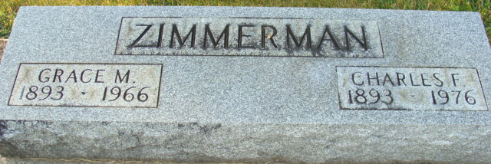
Photo by Alicia Kneuss

Grace Zimmerman Dies Last Evening

Mrs. Grace M. Zimmerman, 72, wife of Charles F. Zimmerman of 511 Nuttman Avenue, died at 9:40 p.m. Wednesday at the Adams County Memorial Hospital. She had been seriously ill for the past week. Born in Bemont, Ill., Oct. 13, 1893, she was a daughter of W.C. and Anna Stoller-Krieg, and had lived in Decatur for 54 years. She was married to Charles F. Zimmerman Feb. 22, 1914, and they celebrated their 50th wedding anniversary two years ago. Mrs. Zimmerman was a member of the First Methodist Church.
Surviving in addition to her husband are one son, Max E. Zimmerman of Lakewood, Colo.; three grandchildren, and one brother, Louis G. Krieg of Ashtabula, O. One daughter, Jean, one brother and one sister preceded her in death.
Funeral services will be conducted at 2 p.m. Saturday at the Winteregg-Linn Funeral Home, with Rev. Melvin R. Seeger officiating. Burial will be in the Decatur cemetery. Friends may call at the funeral home after 7 p.m. Friday until time of the services.

Decatur Daily Democrat, Adams County, Indiana
Thursday, May 5, 1966

