Glen R. Zimmerman
March 3, 1931 – December 10, 2018

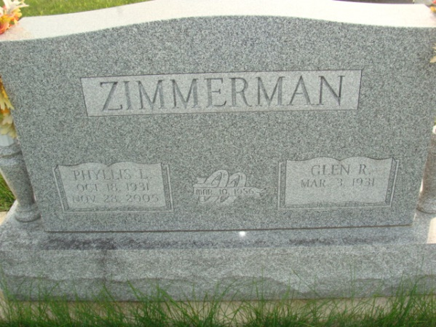
Photo by Alicia Kneuss

Glen R. Zimmerman, 87, of Decatur, Indiana passed away Monday afternoon, December 10, 2018 at Adams Heritage where he had been a resident since June 1 of this year. He was born on March 3, 1931 in Decatur, Indiana to the late Seth D. Zimmerman and the late Bonnie L. (Slusher) Zimmerman. Glen was united in marriage to Phyllis L. Gerke on March 10, 1956 in the Zion Lutheran Church Decatur and she preceded him in death on November 28, 2005.
He served his country during the Korean War in the United States Army. He was honorably discharged at the rank of Private First Class.
Glen was a member of Zion Lutheran Church, Decatur and was a member of the American Legion Post #43 in Decatur.
He was self-employed farmer and retired used car salesman.
He is survived by a sister, Patsy Storck of Fort Wayne and nephews and nieces, Mart Gerke, Patrick Gerke, Peggy Huntley, Joyce Hawkins, Penny Williams, Gregg Noll, Brent Noll, Shari Emenhiser, Duane Zimmerman, Christy Jackson, Lisa Moser, Seth Zimmerman, and Melanie Zimmerman. He was preceded in death by three brothers, Kenneth Zimmerman, Floyd L. Zimmerman and Lloyd Zimmerman.
A funeral service will be held at 10:30 a.m. Saturday, December 15, 2018, at Zwick & Jahn Funeral Home in Decatur with Pastor James Voorman officiating. Burial will follow at Decatur Cemetery with Military Graveside Services provided by the American Legion Post #43 Color Guard.
Family & friends will be received from 3 to 5 and 6 to 8 p.m. Friday, December 14, 2018 at Zwick & Jahn Funeral Home in Decatur and one hour prior to services Saturday also at the funeral home.
Preferred memorials are to Zion Lutheran Church in Decatur.

Zwick & Jahn Funeral Home, Wells County, Indiana
December 11, 2018

