Gertrude (Hahn) Zimmerman
January 3, 1893 – July 25, 1965

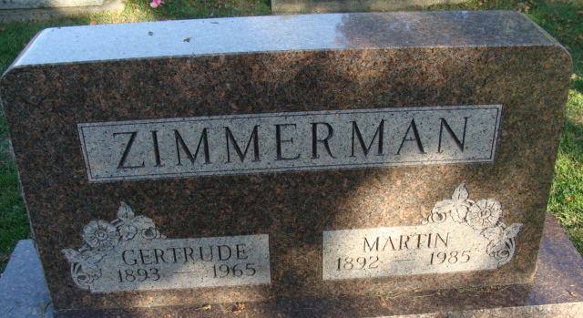
Photo by Alicia Kneuss

Gertrude Zimmerman
in the Indiana, U.S., Death Certificates, 1899-2017
Name Gertrude Zimmerman
[Gertrude Hahn]
Gender Female
Race White
Marital Status Married
Age 72
Birth Date 3 Jan 1893
Birth Place Germany
Death Date 25 Jul 1965
Death Place Fort Wayne, Allen, Indiana, USA
Death Registration Date 1965
Father Karl Hahn
Mother Ida Pultz
Informant Martin Zimmerman; husband
Burial July 28, 1965; Decatur Cemetery; Decatur, Indiana

