George W. Zimmerman
November 20, 1869 – February 7, 1935

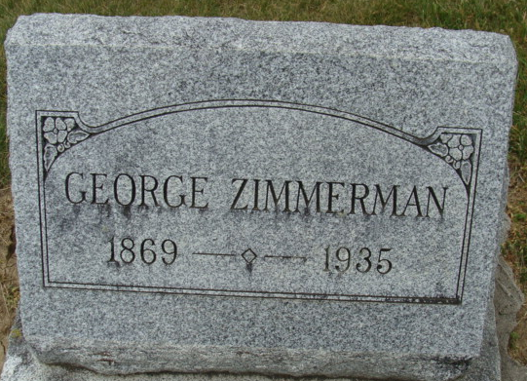
Photo by Alicia Kneuss

George Zimmerman
in the Indiana, U.S., Death Certificates, 1899-2017
Name George Zimmerman
Gender Male
Race White
Marital Status Married
Age 64
Birth Date 15 Nov 1870 (sic)
Birth Place Indiana
Death Date 7 Feb 1935
Death Place Fort Wayne, Allen, Indiana, USA
Death Registration Date 1935
Parents Unknown
Spouse Mary
Informant Mary Zimmerman; wife
Burial February 11, 1935; Decatur, Indiana
**
George W Zimmerman from tree Zimmerman/Bender Family Tree
Birth 20 Nov 1869 Decatur, Adams, Indiana, USA
Marriage 31 Dec 1894 Decatur, Adams, Indiana, USA
Residence 1930 Fort Wayne, Allen, Indiana, USA
Death 7 Feb 1935 Fort Wayne, Allen, Indiana, USA
Father Eli Zimmerman (1842-1894)
Mother Malinda Drayer (1848-1932)
Spouse Cora Pearl Schlegel (1875-1903)
Spouse Jessie Burwell (1878-1929)
Spouse Mary Kegelman (Born 1885)
**
George W. Zimmerman.
Some of the first clearings made in the wilderness of Washington Township of Adams County were effected by the exertions of the Zimmerman family. It is an honored pioneer name. As a family they have been exceedingly industrious, people of splendid business judgment and valuable to the local citizenship as homemakers arid straightforward, honest citizens. One of the present representatives of the family still lives in Washington Township in the person of George W. Zimmerman, whose own career has been in keeping with the high standard set by his forefathers and who is one of the excellent agriculturists of that district.
The Zimmermans as the name indicates are of German origin. The great-grandfather of George W. Zimmerman on coming to America settled in Virginia and spent the rest of his years near Harpers Ferry.
He married and among his sons and daughters was Eli Zimmerman, who was born near Harpers Ferry and when a young man moved to Ohio. From there he came as a pioneer to Washington Township, settling in section 2, where he acquired a section of land and erected a log cabin shelter. It is said that his first crop was four acres of corn. His possessions comprised some of the best black walnut timber land along St. Mary's River. Year by year by persevering industry he cleared his land until 400 acres were under the plow. Later he left his first homestead and moved nearer Decatur, at a time when that town contained only three log houses. Here he made his home until his death on October 29, 1878. He was one of the oldest pioneers and one of the most respected citizens of Adams County, and by his thrift and energy had accumulated property which made him regarded as one of the county's wealthy citizens. All that he had was the fruit of honorable dealing and strict integrity and the comforts of his later years merely repaid the hardships and privations he had endured in early life. He was a member of the Masonic Fraternity and of the Presbyterian Church. His land accumulations at one time totaled more than 600 acres. He married in Adams County Polly Smith, a native of Fayette County, Ohio, and she died in Adams County March 24, 1871. They were the parents of eight children, all of whom grew up and married and had families of their own and all but one lived to mature years. The only one of these children now living is Washington Kerns of St. Mary's Township.
The next generation of the family is represented by Eli Zimmerman, Jr., who was born on the old Zimmerman farm in Adams County, October 23, 1842. This farm is now locally known as the Edward Ahr farm. His early life was spent in a rustic environment, and with only such advantages as were supplied by the schools of Washington Township. Soon after he reached his majority and toward the close of the Civil War he went to the front with a Union regiment but was never engaged in any important battles.
After the war on January 7, 1867, he married Miss Melinda Drayer, who was born in Pennsylvania and spent her early life and received her schooling at Reading. When a young woman she came to Adams County, and after her marriage she and her husband started out as farmers and their mutual labors enabled them to accumulate a fine property in Washington Township, comprising over 1,000 acres of land, some of the best soil in that vicinity.
Eli Zimmerman had the same purposeful activity and energy that marked other members of the family and was a man of influence and substance. Politically he was a democrat. He died at the old farm February 10, 1894, at the age of fifty-one. His widow, who was born in 1848, is now living at Fort Wayne and still possesses all her active faculties. She is a member of the Baptist Church. Three children were born to their marriage, Zachariah dying in early childhood.
The other two are Isaac W. and George W., the former was a native of Adams County, spent many years as a farmer here and died as a result of blood poisoning at Fort Wayne April 1, 1916. He left no surviving children.
George W. Zimmerman was born at the old home of his father in Washington Township on November 20, 1869. His early years were spent on the farm which he still owns and operates. This farm comprises 236 and a fraction of acres, and it has undergone many improvements since Mr. Zimmerman began applying his strength and judgment to its cultivation and management. Some years ago he erected a beautiful two-story modern ten-room house, which is one of the most complete and convenient country residences in the entire county. While he has one of the large farms of the county, Mr. Zimmerman is a thoroughly intensive agriculturist and works and tends his crops with as much method and thoroughness as many who have much smaller holdings.
Mr. Zimmerman married Miss Jessie Burwell, who was born at Bluffton, Indiana, thirty-seven years ago and grew up and received her education in that city. She is a member of one of the noted pioneer families of Wells County, the Burwell’s having located there fully seventy years ago. Her parents were George and Jane (Reed) Burwell, both natives of Ohio, but were married in Bluffton. Her father made a splendid record as a soldier of the Civil war. He went out with an Indiana regiment, saw service in many severe battles, and in one engagement was captured and put in a Confederate prison. After many months of tortuous captivity, he was released and came home nearly starved. In one battle he had lost an eye, but in spite of these handicaps and misfortunes he lived a successful and prosperous life and died in Wells County July 14, 1891, at the age of fifty-one. He was born in Mercer County, Ohio, in 1840, and his wife was born there August 19, 1840, and died at the home of Mrs. Zimmerman April 19, 1913. Mr. and Mrs. Burwell were active Baptists, and he was a Democrat in politics. Mr. and Mrs. Zimmerman are also members of the Baptist Church, and he keeps up the political affiliation of his forefathers. Fraternally he is a member of the Loyal Order of Moose.

Standard History of Adams and Wells Counties, Indiana, John W. Tyndall & Orlo Ervin Lesh; Chicago: Lewis Publishing Co, 1918

