Francis G. Zimmerman
May 13, 1914 – February 8, 1989

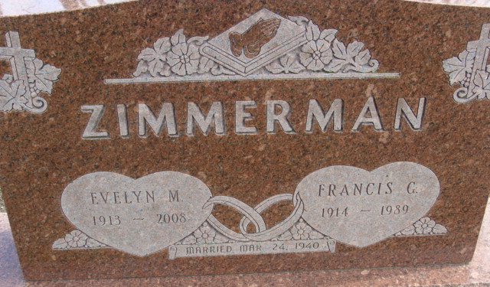
Photo by Alicia Kneuss

Francis G Zimmerman
in the Indiana, U.S., Death Certificates, 1899-2017
Name Francis G Zimmerman
Gender Male
Race White
Marital Status Married
Age 74
Birth Date 13 May 1914
Birth Place Gibson City, Illinois
Death Date 8 Feb 1989
Death Place Fort Wayne, Allen, Indiana, USA
Death Registration Date 1989
Father George Zimmerman
Mother Hilda Onken
Spouse Evelyn M Wright
Informant Evelyn M. Wright; wife; Decatur, Indiana
Burial February 11, 1989; Decatur Cemetery; Decatur, Indiana

