Evelyn M. (Wright) Zimmerman
May 6, 1913 – February 4, 2008

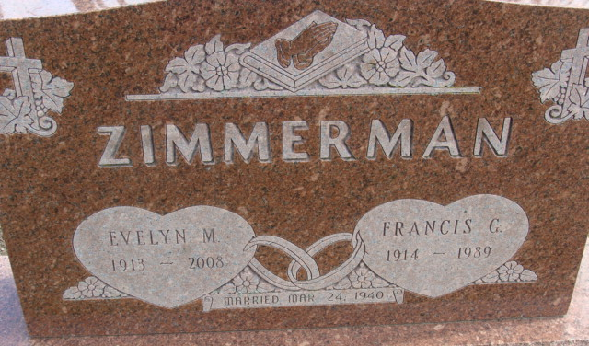
Photo by Alicia Kneuss

Evelyn M. Zimmerman, 94, of Decatur, died Monday, Feb. 4, 2008, at Swiss Village Retirement Center, Berne. Born May 6, 1913, in Anchor, Ill., she was the daughter of the late Elmer Pottis and Mabel Wright. She was a homemaker and member of First Presbyterian Church, Decatur.
Surviving are her son, George J. (Louisa) Zimmer man of Decatur; two grandsons, Patrick (Deb) Kohne of Berne and George Scott (Amy) Zimmerman of New Haven; three granddaughters, Lisa (Brent) Stetler of Monroe, Lori Kohne of Akely, Minn. and Wendy Zimmerman of Decatur; and six greatgrandchildren. She was also preceded in death by her daughter, Karen Kay Kohne; and one grandson.
Funeral service is 11 a.m. Friday at Haggard & Sefton Funeral Home, Decatur; the Rev. Troy Green officiating. Visitation is from 4 to 8 p.m. today at the funeral home. Burial in Decatur Cemetery, Decatur. Memorials to Family Hospice of Northeast Indiana.

News-Sentinel, Allen County, Indiana
February 7, 2008

**
Indiana, U.S., Death Certificates, 1899-2017
Name Evelyn M Zimmerman
[Evelyn M Wright]
Maiden Name Wright
Gender Female
Race White
Marital Status Widowed
Age 94
Birth Date 6 May 1913
Birth Place Anchor, Illinois
Death Date 4 Feb 2008
Death Place Berne, Adams, Indiana, USA
Father Clarence H Wright
Mother Mabel Pottis
Informant George Zimmerman; son; Decatur, Indiana
Burial Decatur Cemetery; Decatur, Indiana

