Eli Zimmerman
October 23, 1842 – February 10, 1894

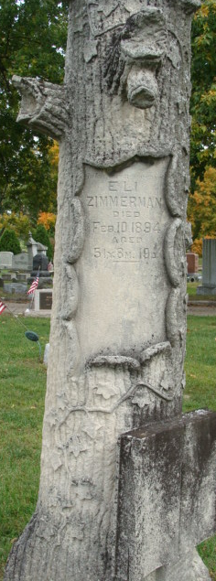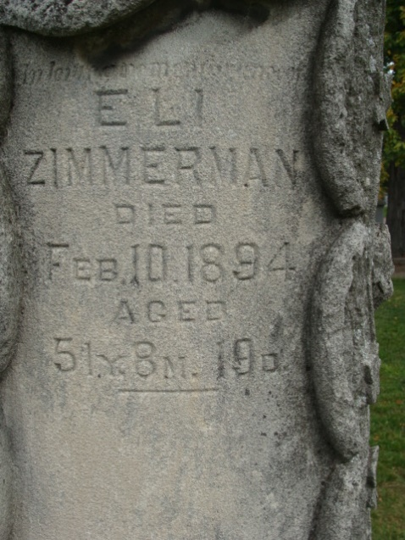
Photo by Alicia Kneuss

Eli Zimmerman was born in Washington Township, Adams County, Indiana, October 23, 1842, and died February 10, 1894, age 51 years, 3 months, and 19 days. He was the son of Eli and Polly Zimmerman, the father was born near Harper's Ferry, Maryland. Eli Zimmerman was reared amid pioneer scenes on his father's farm, and on the one which he lived and died. His education was received in our Public schools at which in those days consisted of only a few months in the year. His landed estate in Washington Township consisted of about 1000 acres of choice land. He was married to Miss Melinda Dryer, a native of Pennsylvania in 1867, and to them were born three children, - two of them now living, George and Isaac.
The funeral services were held in the M. E. church of our city, and were conducted by Rev. H. H. Smith of the Baptist church, assisted by Rev. E. T. Gregg, of the M. E. church; Sam Henry Post of our city, of which the deceased was a member performing their part of the services at the close.
While the weather was the most inclement that could be expected, caused by the greatest snow-storm ever witnessed in Decatur by the oldest inhabitant, the church was filled with friends and relatives of the deceased, and seldom, if ever, was there a greater attendance of all the professions and avocations of our city than on this occasion. The immediate relatives of the deceased and the pall-bearers from Sam Henry Post accompanied the remains to Maple Wood Cemetery where they were laid to rest, mourned by a large circle of friends and relatives.

Decatur Daily Democrat, Adams County, Indiana
February 16, 1894

**
Eli Zimmerman from tree Zimmerman/Bender Family Tree
Birth 23 Oct 1842 Adams, Indiana, USA
Marriage 6 Jan 1867 Allen, Indiana, USA
Residence 1894 Allen, Indiana, USA
Death 10 Feb 1894 Adams, Indiana, USA
Father Eli Zimmerman (1802-1878)
Mother Mary "Polly" Smith (1803-1871)
Spouse Malinda Drayer (1848-1932)

**
ELI ZIMMERMAN, one of the prosperous and enterprising agriculturists of Washington Township, is a native of Adams County, Indiana, born October 23, 1842, a son of Eli and Polly Zimmerman, the father born near Harper's Ferry, Maryland, and the mother a native of Fayette County, Ohio. They were the parents of eight children, and of this number five are living - Nancy, Jane, Polly, Eli and Elizabeth. The father was one of the early pioneers of Washington Township, settling on section 2, where he entered a section of land on which he first erected a log cabin, and the first season raised four acres of corn. Year by year he, by persevering industry, cleared his land until 400 acres had been cleared and improved. He then removed to Decatur, settling on the St. Mary's River when there were but three log houses in Decatur, and here he made his home until his death, which occurred October 29, 1878, his wife dying March 24, 1871. In his death Adams County lost one of her oldest pioneers and a most respected citizen. He had, like all pioneers, to undergo many hardships and privations, but he lived to enjoy the fruits of his years of toil, and by his honorable dealings and strict integrity he gained the confidence of the entire community. He was a member of the Masonic fraternity. In his religious faith he was a Presbyterian.
Eli Zimmerman, whose name heads this sketch, was reared amid pioneer scenes on his father's farm in Washington Township. His educational advantages were very limited, his youth being spent in working on the farm. As a farmer he has met with excellent success, having accumulated his present fine property in Washington Township, which consists of about 935 acres of choice land. January 7, 1867, he was united in marriage to Miss Melinda Drayer, a native of Pennsylvania. Of the three children born to Mr. and Mrs. Zimmerman two are living - Isaac W. and George W. In his political affiliations Mr. Zimmerman is a Democrat.

Biographical and Historical Record - Adams and Wells Co. Indiana Lewis Publishing Co. Chicago, IL 1887

