Deon R. Zimmerman
December 16, 1959 – August 28, 1970

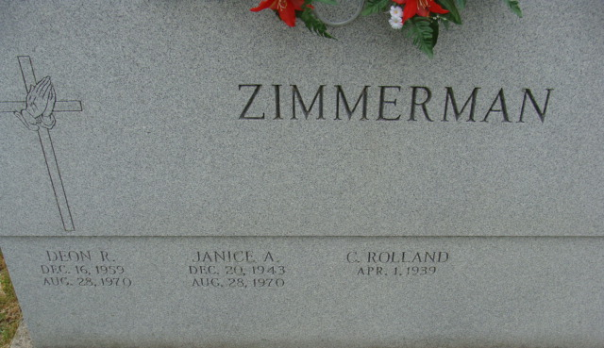
Photo by Alicia Kneuss

Deon Zimmerman, 10, Second Victim of Friday’s Accident; to hold services Monday

Friday’s tragic accident south of Decatur claimed its second life when Deon Zimmerman, age 10, died at Fort Wayne Lutheran Hospital of injuries sustained in a one-car accident earlier in the day. Deon died at 6:55 p.m. Friday.
His mother, Mrs. Rolland (Janice) Zimmerman, 26, of 320 ½ Winchester St., the driver of the car, was dead on arrival at the Adams County Memorial Hospital, following the mishap. The one-car mishap took place shortly before 11 a.m. Friday just south of the Decatur Church of God and the new Lakeview Nursing Home. Mrs. Zimmerman lost control of her auto and the vehicle went down a steep embankment along U.S. Highway 33.
Troy In Fair Condition
The other Zimmerman boy, Troy, age 8, was listed in “fair condition” in the intensive care unit of the Lutheran Hospital. He received a broken jaw and a cracked leg in the accident.
Funerals Monday
Double funeral services for Mrs. Zimmerman and her son will be conducted at 2 p.m. Monday at the Decatur Church of God, with Rev. James E. Johnson officiating. Burial will be in the Decatur Cemetery.
Friends may call at the Winteregg-Linn Funeral Home from 10 a.m. Sunday until 11:30 a.m. Monday, then at the church from 12 noon until time of the services. Preferred memorials are to the Church of God youth fund.
Mrs. Zimmerman was born in Berne Dec. 20, 1943, a daughter of Mel and Celeste Lehman-Liechty, and was married to C. Rolland Zimmerman July 11, 1959.
A member of the Church of God, she and her husband served as youth counselors for the young people of the church. Mrs. Zimmerman was also employed part time as a beautician.
Surviving in addition to her husband and son Troy, are her parents, Mr. and Mrs. Mel Liechty of Berne Route 1; two sisters, Mrs. James (Dianne) Taylor of Monroe Route 1, and Mrs. Ronald (Patricia) Brown of Muncie; two brothers, Melvin Liechty II, and Barry Liechty, both of Berne Route 1; the maternal grandmother, Mrs. Wilbur E. Lehman of Berne; and the paternal grandfather, Robert U. Liechty of Berne.
Deon R. Zimmerman was born in Decatur Dec. 16, 1959. The lad was a member of the Church of God and the youth of the church, and was active in 4-H work. He would have been a fifth-grade student at the Lincoln School this fall. He was a newspaper carrier boy for the Decatur Daily Democrat.
Surviving in addition to his father and brother are the maternal grandparents, Mr. and Mrs. Mel Liechty of Berne Route 1; the paternal grandparents, Mr. and Mrs. Walter Zimmerman of Decatur Route 2, the maternal great-grandmother, Mrs. Wilbur E. Lehman of Berne; the maternal great-grandfather, Robert U. Liechty of Berne; the paternal great-grandfather, Albert Roth of Decatur Route 2; and the paternal great-grandmother, Mrs. Elva Killenger of Poe.

Decatur Daily Democrat, Adams County, Indiana
Saturday, August 29, 1970

