Cora Pearl (Schlegel) Zimmerman
July 24, 1875 – July 15, 1903

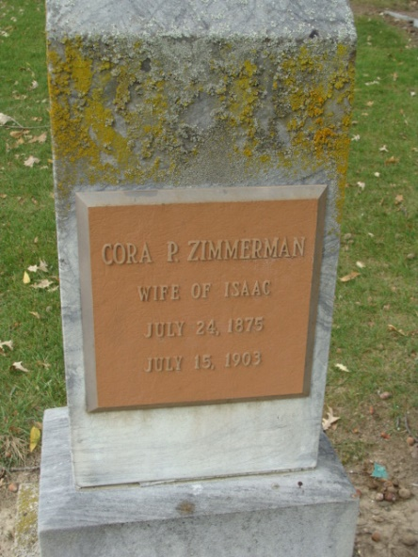
Photo by Alicia Kneuss

Mrs. Cora Zimmerman died at the home of Augustus Schlegel, her father, on Line Street yesterday about four o’clock after an extended illness with kidney trouble. She had been very low for several days past and was not expected to live although her condition yesterday showed some improvement and the end was not looked for so soon.
The deceased would have been twenty-eight years old on the twenty-fourth of this month and has lived in this city, the place of her birth, during her entire lifetime. She was married several months ago to Ike Zimmerman and their three weeks old child was buried just a short time ago. She had been married once previous, and a four-year-old son survives her.
The funeral services will be held from the United Brethren Church on Friday morning, Rev. Pontius officiating. Interment at Maplewood Cemetery.
Besides her son, her father and mother, one brother, Lawrence, survives her. The remains may be viewed Thursday afternoon from four o’clock anil Thursday evening from six to eight.

Decatur Democrat; Adams County, Indiana
a weekly newspaper
Thursday, July 16, 1903

**
Cora Pearl Zimmerman
in the Indiana, U.S., Death Certificates, 1899-2017
Name Cora Pearl Zimmerman
[Cora Pearl Schlegel]
Gender Female
Race White
Marital Status Married
Age 27
Birth Date 24 Jul 1875
Birth Place Adams, Indiana
Death Date 15 Jul 1903
Death Place Decatur, Adams, Indiana, USA
Death Registration Date 1903
Father Gust Schlegel
Mother Mary J. [Grim]
Informant Mary J. Grim; Decatur, Indiana
Burial July 17, 1903; Decatur Cemetery

