Charles F. Zimmerman
May 6, 1893 – May 30, 1976

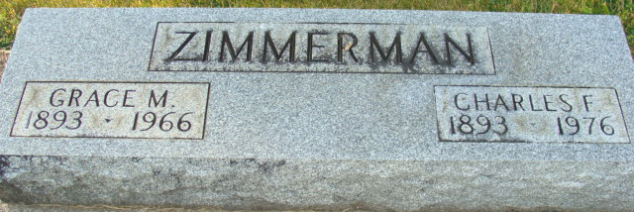
Photo by Alicia Kneuss

Charles F. Zimmerman
in the Indiana, U.S., Death Certificates, 1899-2017
Name Charles F. Zimmerman
Gender Male
Race White
Marital Status Widowed
Age 83
Birth Date 6 May 1893
Birth Place Indiana
Death Date 30 May 1976
Death Place Decatur, Adams, Indiana, USA
Death Registration Date 1976
Father Ezra E. Zimmerman
Mother Alice Pierce
Informant Max Zimmerman; son; Lakewood, Colorado
Burial June 2, 1976; Decatur Cemetery; Decatur, Indiana

