C. Rolland Zimmerman
April 1, 1939 – March 27, 2018

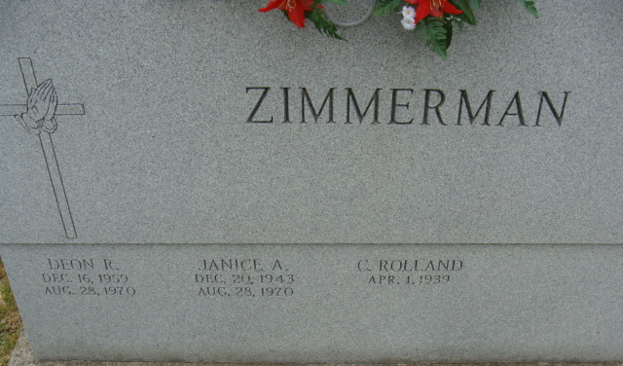
Photo by Alicia Kneuss

Rollie Zimmerman, 78, of Decatur, Indiana passed away unexpectedly on Tuesday afternoon, March 27, 2018 at Adams Memorial Hospital ER. He was born on April 1, 1939 in Adams County, Indiana to the late Walter R. Zimmerman and the late Verrea I. (Roth) Zimmerman. He was married to Janice Liechty and she along with their son, Deon, both preceded him in death in 1971 in an automobile accident. On March 20, 1975, he married Julie Luginbill at Waynedale Baptist Church.
A 1958 graduate of Adams Central High School, Rollie was a cheerleader and served as Homecoming King of his senior class. He was employed at LICA Construction for 43 years from 1961 to 2004. Rollie sold cars since 1976 and started out in sales as a Fuller Brush man. Rollie was a member of the Decatur Church of God where he had previously served as the youth pastor for eight years. He was also a member of the Teamsters Union.
From 1971 to 1977, Rollie was affiliated with the gospel group, The Imperials; that played back-up for Elvis Presley. He was also affiliated with the gospel group The Gaither Brothers and helped to organize shows in Adams County for both groups. Rollie served as the emcee for Suzy Fuelling Dance Revues & the Miss Adams County pageant for several years. He had a radio show on WADM called Uplift that aired every Sunday. His biggest joys in life were his children and grandchildren.
He is survived by his wife, Julie of Decatur; daughter, Amy Zimmerman of Decatur; six sons, Troy (Pam) Zimmerman, Mark Zimmerman, Aaron Zimmerman, Clint (Heather) Zimmerman, Ian (Myrna) Zimmerman; and Evan (Sabrina) Zimmerman, all of Decatur; two sisters, Pansy Hullinger; and Paula Zimmerman both of Decatur; three brothers, Marshal (Sandy) Zimmerman of Monroe, Rick Zimmerman of Decatur; and Tracy Zimmerman of Fremont; 22 grandchildren; nine great-grandchildren; and one grandchild on the way. Rollie was preceded in death by two sisters, Arlene Strickler and Gloria Bienz.
A funeral service will be held at 10:30 a.m. Saturday, March 31, 2018 at the Decatur Church of God with Rev. Dr. Robert Brink officiating. Interment will follow at Decatur Cemetery. Family and friends will be received from 2 to 8 p.m. Friday, March 30, 2018 at the Zwick and Jahn Funeral Home in Decatur and one hour prior to the service at the church on Saturday.
Preferred memorials are to the Decatur Church of God.

Zwick & Jahn Funeral Home, Adams County, Indiana
March 28, 2018

