Bessie Anna (Young) Zimmerman
December 25, 1961 – May 4, 1928

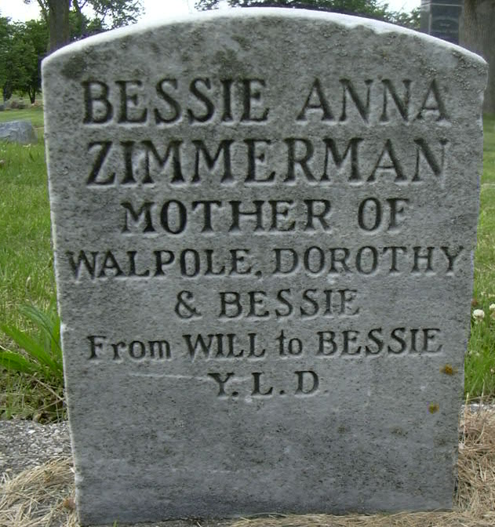
Photo by Deb Curry

Root Township Resident Dies
Mrs. William Zimmerman Succumbs to Illness of Uremic Poisoning
Mrs. Bessie A. Zimmerman, 66, wife of William Zimmerman of Root Township, died at 5:30 o'clock yesterday afternoon at the Zimmerman home in the northern part of Adams County, following an illness of a week's duration. Death was said to have been due to uremic poisoning. Mrs. Zimmerman became ill last Sunday and never regained consciousness.
Bessie Young Zimmerman was born December 25, 1861, in Allen County. She was the daughter of Steven Young and Margaret Aker Young. Five years ago, Mr. and Mrs. Zimmerman moved to Adams County where they have since resided.
Surviving, besides the husband, are two daughters, Dorothy M. Johnson of St. Louis, Mo., and Bessie L. Blow, of Detroit, Michigan. One son [Walpole/Paul Henry Liger] preceded the other in death several years ago. A brother, Tillman Young, of Fort Wayne, also survives.
Funeral services will be held Monday afternoon at 2 o'clock at the home in Root Township. Burial will be made in the Decatur Cemetery. The Rev. R. W. Loose, of the Evangelical Church of this city, will have charge of the services.

Decatur Daily Democrat, Adams County, Indiana
June 5, 1928

