William Zerkel
February 21, 1846 – March 16, 1909

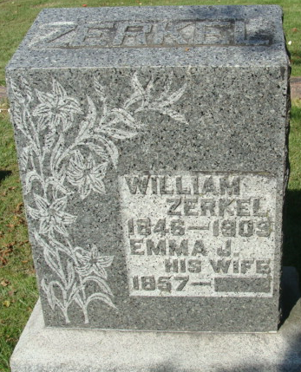
Photo by Alicia Kneuss

PROMINENT ADAMS COUNTY FARMER IS DEAD
(By Kist News Bureau)

DECATUR, Ind. - March 17- William Zerkle, a prominent farmer of this community, died at midnight at his home, five miles south of the city, after a week’s illness with pneumonia. The deceased was 63 years old. He was born in Champaign County, Ohio, but for many years, he and his wife, to whom he was married 36 years ago, had been residents of this county. He was a soldier of the civil war and was with Sherman during the period of his greatest activity.
The funeral will be held Friday afternoon at 2 o'clock from the Evangelical Church in this city. The GAR will attend in a body.

Journal-Gazette, Allen County, Indiana
March 18, 1909

**
Indiana, U.S., Death Certificates, 1899-2017
Name William Zerkel
Gender Male
Race White
Marital Status Married
Age 63
Birth Date 21 Feb 1846
Birth Place Sheshequin Co Ohio
Death Date 16 Mar 1909
Death Place Washington, Adams, Indiana, USA
Father Serem Zerkle
Mother Nieves???
Spouse Emma
Informant Emma Zerkel; Decatur, Indiana
Burial Decatur Cemetery

