Wayne S. Zerkel
January 20, 1913 – May 8, 1972

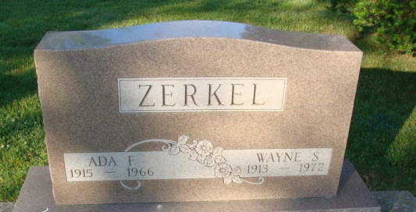
Photo by Alicia Kneuss

Wayne S. Zerkel, 59, of 5839 Radcliff Drive, Fort Wayne, Production engineer for Central Soya, Fort Wayne, a native and former resident of Decatur, died at 1:54 p.m. Monday at the Lutheran Hospital in Fort Wayne. He had been ill since December. Mr. Zerkel had been associated with Central Soya for 36 years, from 1934 until his retirement last year. He began employment at the Decatur plant when it was started in 1934, the parent plant of the company. He served as plant manager for Central Soya at Marion, O., Gibson City Ill., and Memphis, Tenn. He returned to Fort Wayne as production engineer in 1954. He was born in Decatur, Jan 20, 1913, a son of Hubert E. and Mary Shilling-Zerkel, and was a graduate of the Decatur High School. He was married to Ada Savieo Aug 6, 1932. His wife preceded him in death June 1. 1966. Mr. Zerkel was a member of the Epworth United Methodist Church at Fort Wayne. Decatur Lodge 571, F&AM, Al Chymia Temple of Memphis and Club Olympia of Fort Wayne.
Surviving are one son, Jack Zerkel of fort Wayne; his father Hubert E. Zerkel, Decatur, retired rural mail carrier; one brother Hubert E. Zerkel Jr. principal of the Bellmont High School here; two sisters, Mrs. Sylvester (Justine) Everhart and Miss Margaret Zerkel both of Decatur; and two grandchildren.
Funeral Services will be conducted at the Zwick Funeral Home, with Rev. Jim M. Fritz officiating. Burial will be in the Decatur Cemetery. Friends may call at the funeral home after 2 p.m. today until time of service. Preferred memorials are to the church or to the American Cancer Society.
Pallbearers will be George Albright, Robert Syster, Robert Culler, L. E. Meyer, Ralph Keyton, Ollie Morgan and Ellis Ables. Contributed by John Page.

Journal Gazette, Allen County, Indiana
May 9, 1972

**
WAYNE ZERKEL, CENTRAL SOYA ENGINEER, DIES

Wayne F. Zerkel, 59, of 5839 Radcliffe Drive, died at 11:54 p.m. yesterday in Lutheran Hospital. He had been ill since December. Mr. Zerkel was production engineer for Central Soya Co. Associated with Central Soya for 36 years; he joined the company in 1934 in Decatur. He later transferred to Gibson City, Ill., and then to Marion, Ohio, as plant manager. After serving as plant manager in Memphis, Tenn., he returned to Fort Wayne in 1954 as production engineer. He was a native of Decatur. He is survived by his father, Rupert (sic) E. Decatur; a son, Jack; two sisters, Mrs. Sylvester (Justine) Everhart, and Miss Margaret Zerkel, Decatur; one brother, Hubert E. Zerkel Jr., Decatur, principal of Belmont High School, Decatur, and two grandchildren. Services will be at 2 p.m. Wednesday in Zwick Funeral Home, Decatur, the Rev. Jim M. Fritz officiating. Burial will be in Decatur cemetery. Friends may call at the funeral home after 2 p.m. today. Mr. Zerkel was a member of the Epworth United Methodist Church, Fort Wayne; Decatur Lodge 571, F&AM; AI Chymia Temple of Memphis; and Club Olympia, Fort Wayne. Pallbearers will be George Albright, Robert Syster, Robert Culler, L. E. Meyer, Ralph Kenyon, Ollie Morgan, and Ellis Ables.
Preferred memorials are to the church or the Allen County Cancer Fund.

Unknown source

