Robert Wayne Zerkel
March 10, 1934 – January 10, 1936

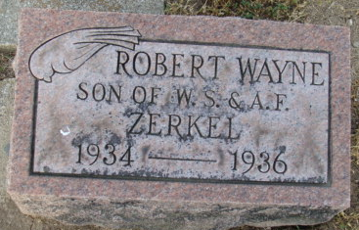
Photo by Alicia Kneuss

Robert Zerkel
in the Indiana, Death Certificates, 1899-2011

Name: Robert Zerkel
Gender: Male
Race: White
Age: 1
Marital Status: Single
Birth Date: 10 Mar 1934
Birth Place: Indiana
Death Date: 10 Jan 1936
Death Place: Indianapolis, Marion, Indiana, USA
Father: Wayne Zerkel
Mother: Ada Savieo
Burial: Jan. 12, 1936 Decatur Cem.

