Oceano J. (Bell) Zerkel
September 17, 1866 – February 5, 1955

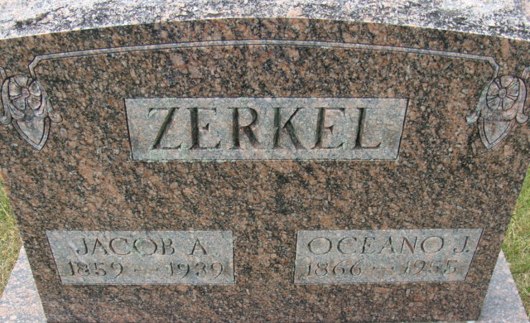
Photo by Alicia Kneuss

Mrs. Jacob Zerkel Is Taken by Death Funeral Services Tuesday Afternoon

Mrs. Oceano Zerkel, 88, of North Eleventh Street, died at 8:55 o'clock Saturday night at the Adams County Memorial Hospital, where she had been a patient since suffering a fractured hip Nov. 7 She was born in French Township Sept. 17, 1866, a daughter of Vincent and Sarah Alexander Bell and was married to Jacob A. Zerkel Dec. 24, 1885. Her husband preceded her in death Sept. 1, 1939. The family had lived in Decatur since 1926. Mrs. Zerkel was a member of the Trinity Evangelical United Brethren church.
Surviving are one son, Hubert E. Zerkel of Decatur; two daughters, Mrs. Ray Smith and Mrs. Ed Kelly, both of Decatur; 17 grandchildren; 25 great-grandchildren; one great-great grandchild, and two brothers. Three sons, three daughter, five sister and three brothers are deceased.
Funeral services will be conducted at 2:30 p.m. Tuesday at the Zwick Funeral Home, the Rev. John E. Chambers officiating. Burial will be in the Decatur Cemetery. Friends may call at the funeral home until time of the services.

Unknown source

**
Mrs. Zerkel, 88, Dies at Decatur
Fractured hip proves fatal; Funeral on Tuesday.
Mrs. Oceano Zerkel, 88, a life-long resident of Adams County, died at 8:55 p.m. Saturday at the Adams County Memorial Hospital where she had been a patient since suffering a fractured hip on November 7. She had resided in Decatur since 1926 and was a member of the Trinity Evangelical United Brethren Church in that city.
Surviving are a son, Hubert E., Decatur, two daughters, Mrs. Ray Smith and Mrs. Ed Kelly, both of Decatur; 17 grandchildren; 25 great-grandchildren; one great-great-grandchildren and two brothers.
Mrs. Zerkel was born in French Township Sept. 17, 1866, the daughter of Vincent and Sarah Alexander Bell. She was married to Jacob A. Zerkel Dec. 24, 1885 and he preceded in death Sept. 1, 1939.
Three sons, three daughters, five sisters and three brothers are deceased. One of the deceased sons is Kenneth Zerkel who died suddenly at Ft. Wayne a few years ago.
The body is at the Zwick Funeral Home in Decatur where friends may call and where services will be held at 2:30 p.m. Tuesday, with the Rev. John E. Chambers officiating. Burial will be in the Decatur Cemetery.

Adams County Historical Museum, Adams County, Indiana
February – April 1955 Scrapbook
Handwritten date: Monday, February 7, 1955

