Mary G. (Shilling) Zerkel
October 24, 1887 – May 25, 1968

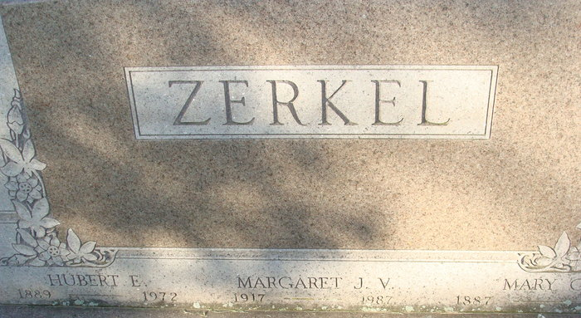
Photo by Alicia Kneuss

MRS. MARY ZERKEL DIES AT HOSPITAL

Mrs. Mary G. Zerkel, 80, wife of Hubert E. Zerkel, Sr. 417 North Fifth Street, died at 8:51 p.m. Saturday at the Adams Co. Memorial Hospital. Mrs. Zerkel, a former school teacher, had been in failing health for the past year and critically ill for two weeks. A daughter of Joseph and Margaret Troutner-Shilling, she was born in Adams Co., October 24, 1887, and was a lifelong resident of the county. She was married to Hubert E. Zerkel September 28, 1909. Mrs. Zerkel, a former school teacher in Washington Township, was a member of the First United Methodist Church, the W.S.C.S of the church, and the Order of Eastern Star.
Surviving are her husband; two daughters; Mrs. Sylvester (Justine) Everhart of Decatur, Miss Margaret J. Zerkel, at home; two sons, Wayne S. Zerkel of Fort Wayne and Hubert Zerkel, Jr., principal of the Bellmont High School; seven grandchildren, seven great-grandchildren, one brother, Lewis Shilling, preceded her in death.
Funeral Services will be conducted at the Winteregg-Linn Funeral Home, with Rev. Melvin Seeger and Rev. Noel G. Reed officiating. Burial will be in the Decatur Cemetery. Friends may call at the funeral home after 7 p.m. today until 1 p.m. Tuesday, when the casket will be closed.

Decatur Daily Democrat, Adams County, Indiana
May 27, 1968

