Margaret J. V. Zerkel
November 30, 1917 – October 4, 1987

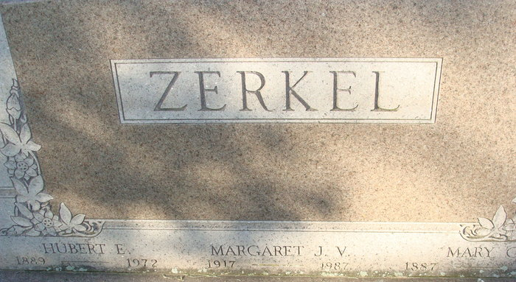
Photo by Alicia Kneuss

DECATUR – Margaret Zerkel, 69, died at 6:25 p.m. Sunday in Byron Health Center, Fort Wayne.
Surviving are one sister and one brother.
Services at 1 p.m. Wednesday in Winteregg-Linn & Haggard Funeral Home; calling 7 to 9 p.m. today.

Journal-Gazette, Allen County, Indiana
October 6, 1987

**
Indiana Births, 1880-1920 Record
Name: Zerkel, M. V
Father: Hubert Mother: Mary Shilling
County: Adams
Gender: F;
Birth Date: 30 Nov 1917

Reference: Adams County, Indiana Index to Birth Records, 1882 - 1920 Inclusive. Volume I, Letters A - Z Inclusive, Book: H-17, Page: 78

