Jacob A. Zerkel
April 2, 1859 – September 1, 1939

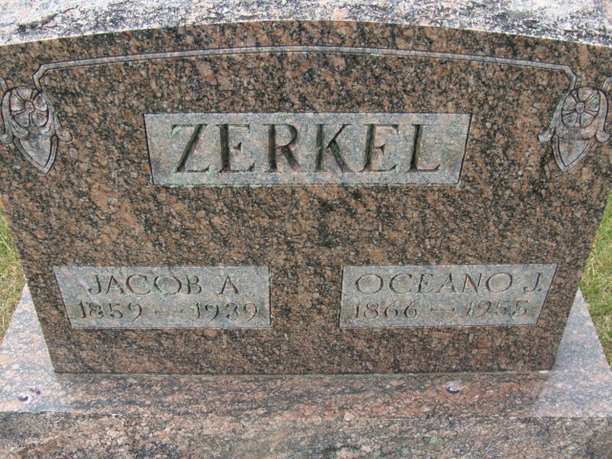
Photo by Alicia Kneuss

DEATH CLAIMS J. A. ZERKEL
Retired Farmer Dies This Afternoon At Home In This City

J. A. Zerkel, 80, prominent retired farmer, died at 12:10 o'clock this afternoon at his home on North Eleventh Street. Death was attributed to complications. The deceased had been residing in this city for some time, having retired from active farming life in Kirkland and Root Townships. He was also engaged in the carpenter trade for a number of years.
Surviving, besides the widow, Ocie Bell-Zerkel, are the following children: Hubert, local mail carrier; Mrs. Ray Smith, Mrs. Frank Drake and Mrs. Ed Kelly, all of Decatur, Mrs. Ralph Schnepp of Huntington and Kenneth Zerkel of Linn Grove. Two sons and a daughter are deceased. The daughter, Neva, died exactly five years ago today. There are no brothers or sisters surviving.
The body was to be taken to the Zwick Funeral Home this afternoon, and then returned to the residence until time for the funeral. Funeral services will be held at the home at 10 a.m. Monday, with Rev. James A. Weber and Rev. C. J. Miner officiating. Burial will be in the Decatur Cemetery.

Decatur Daily Democrat, Adams County, Indiana
September 1, 1939

**
Indiana, U.S., Death Certificates, 1899-2017
Name Jacob H Zerkel
Gender Male; Race White
Marital Status Married
Age 80
Birth Date 2 Apr 1859; Birth Place Indiana
Death Date 1 Sep 1939; Death Place Decatur, Adams, Indiana, USA
Father Wm [Sarem] Zerkel
Mother Aciano B. Bell [this is his wife]
Informant Hubert Zerkel; Decatur, Indiana
Burial September 4, 1939; Decatur Cemetery

